Ideation Phase
Brainstorm & Idea Prioritization Template

Date | 14 Feb 2026
Team ID | LTVIP2026TMIDS52481
Project Name | Dog Breed Identification using Transfer Learning
Maximum Marks | 4 Marks

Brainstorm & Idea Prioritization Template:
Step-1: Team Gathering, Collaboration and Select the Problem Statement
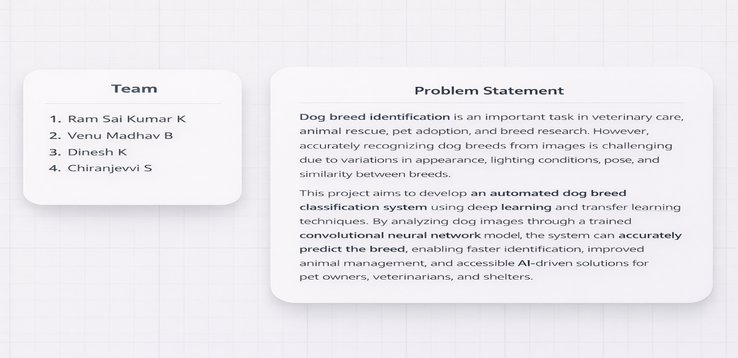

Step-2: Brainstorm, Idea Listing and Group
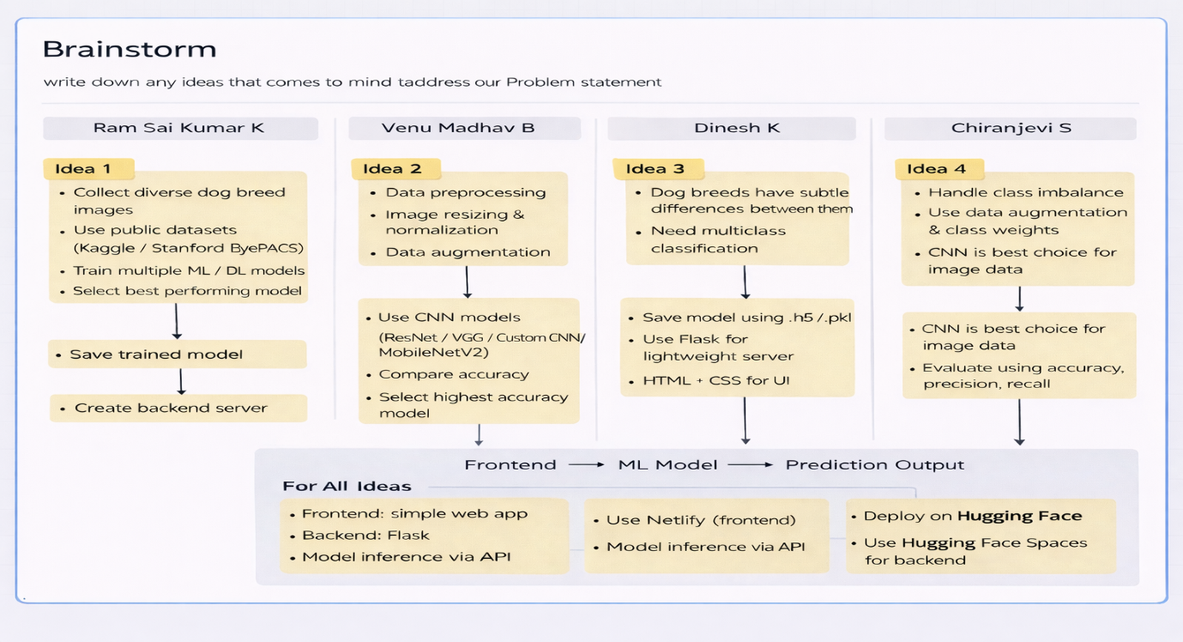

Brainstorm – Group Idea Flow (Dog Breed Classification)
1. Data Collection
• Collect dog images for multiple breeds
• Use publicly available datasets from Kaggle dog-breed dataset
• Ensure balanced images for each breed class
2. Data Preprocessing
• Resize images to MobileNetV2 input size (224×224)
• Normalize pixel values
• Apply data augmentation (flip, rotation, zoom)
• Improve model generalization and reduce overfitting
3. Problem Understanding
• Dog breed identification is a multiclass image classification problem
• Requires learning fine visual differences between breeds
• High-dimensional image data handled using deep learning
4. Model Selection
• Use Transfer Learning with MobileNetV2
• Fine-tune final layers for dog-breed classes
• Compare training accuracy and validation accuracy
• Select best-performing trained model
5. Handling Challenges
• Manage class imbalance in dataset
• Use augmentation and proper train-validation split
• Prevent overfitting with dropout and regularization
6. Model Training & Saving
• Train MobileNetV2 on prepared dataset
• Save trained model in .h5 format
• Prepare model for inference and deployment
7. Backend Development
• Build backend using Flask
• Load trained MobileNetV2 model
• Create prediction API for uploaded dog images
8. Frontend Development
• Design simple web interface using HTML, CSS, JavaScript
• Provide image upload and preview
• Show predicted dog breed with confidence score
9. System Integration
• Connect frontend with Flask backend
• Send uploaded image to model API
• Display prediction result and probability

10. Deployment
• Deploy trained model and app using Hugging Face Spaces
• Ensure public access through web browser
• Enable real-time prediction from anywhere
11. Final Output Flow
User Upload → Flask Backend → MobileNetV2 Model → Dog Breed Prediction → Result Display
Step-3: Idea Prioritization
